Stroud District Councillors’ Report – February 2023
Report of meetings during January and February 2023

All Stroud District Council and Committee papers can be found here: https://www.stroud.gov.uk/council-and-democracy/meetings Recordings of meetings are available via the Committee meeting webpage on the Council’s You Tube channel: https://www.youtube.com/channel/UCeH_AmF0s-TShcYlM8Stweg

Development Control Committee – 17th January
Parcel R17 EL, Hunts Grove Phase 4, Hunts Grove Drive, Hardwicke, S.22/0460/FUL
Full planning permission for residential development (Use Class C3), community hub (Use Class E), local retail and commercial space (Use Class E), allotments, bio-diversity habitat and associated infrastructure and landscape works. Refused.

Community Services & Licensing – 26th January
Cost of Living Crisis - Committee discussed the paper showing a big increase in demand for support due to the Cost of Living Crisis (link):
- Stroud Foodbank – 700 Food parcels given out in December and 700 Christmas hampers. In 2022, the Foodbank saw a 73.7% increase on 2021 and a 123% increase on 2019 (pre-pandemic).
- Stroud Citizens Advice – In Quarter 4 of 2022 they saw a 103% increase in the number of clients needing to access charitable support and foodbanks compared to the same period in 2021.
- SDC Household Support Vouchers – £35,100 of supermarket vouchers distributed to front line services and community groups since October 2022.This includes Community Hubs, Foodbanks and Citizens Advice.
The number of clients by ward who are presented to Citizens Advice with a financial crisis /issue in 2022 increased by more than 80% compared with the previous year in most wards.
In the Wotton-under-Edge Ward (covering Wotton, North Nibley and Stinchcombe parishes) the number of people who have been supported by Citizens Advice with a financial crisis issue increased from 13 in 2021 to 25 in 2022 (increase of 92%).
The year on year comparison (below) for 2019 – 2022, shows the clients who came to the Stroud & Cotswold Districts Citizens Advice because they couldn’t afford to eat or were in need of other financial assistance.
The blue line on the chart shows that demand for support has been increasing year on year and was significantly higher during 2022 than previous years.
SDC has a Cost of Living working group which meets monthly to review the impact of the cost of living crisis and actions that can be taken to support residents and council tenants.
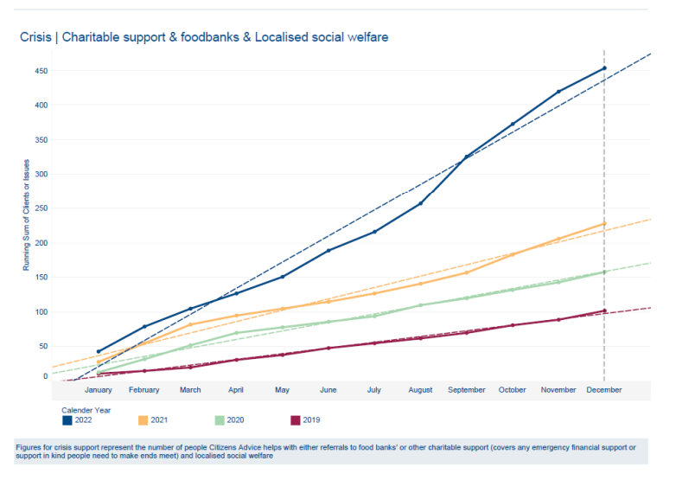

Tennis Courts, Stratford Park Stroud - The Committee approved refurbishment of the 6 tennis courts at Stratford Park Leisure Centre within the park – to include resurfacing, new fencing where required, new posts and nets to all courts, a gate access entry system added to each block of two courts and an online central booking system. The total cost is just over £127,000. The Lawn Tennis Association is providing a grant of over £115,000, and Active Gloucestershire is providing a further £5,000. Stroud District Council will contribute the final £7,000 from the existing health & wellbeing budget.
Police and Crime Panel Report – mention of the second meeting at the Subscription Rooms in Stroud (on 24 January) on the subject of recent attacks on women in Stroud. Police officers, the Police and Crime Commission, SDC and others will be attending to provide an update and take questions.
Update on Local Authority Trading Company (LATC) – a brief update on work that is progressing to set up a new Local Authority company to manage the two leisure centres at Stratford Park and The Pulse from October 2024 when the current contract with Sports Leisure Management for the Stratford Park Leisure Centre ends. A report will be presented at the March meeting.

Housing Committee – 31st January
15 new homes for refugees from Ukraine & Afghanistan - On 21st December the Government launched the ‘Local Authority Housing Fund’, a new fund to support Local Authorities with the purchase of properties to house households fleeing conflict in Ukraine and Afghanistan. SDC has been given an indicative allocation of £1.8m to purchase 15 properties. Housing Committee agreed to submit an expression of interest. Longer term these properties will be available as part of the council’s housing stock for any households in need of council housing once the current crises have passed. (link)
Out of Hours Service Provision – discussed the failure of the SDC out of hours call handling service under its contract with Orbis on 17th/18th December when snow rapidly thawed causing problems for many council housing tenants with frozen and then burst pipes causing flooding, and failed boilers. Staff from the Property Care team and contractors worked hard to visit tenants, make repairs where possible and deliver electric heaters where tenants boilers had broken. The spike in demand due to the change in weather conditions was experienced across the country. Additional back up arrangements to support the out of hours service were put in place over the Christmas period, which passed without incident. The terms and conditions of the SDC contact with Orbis are currently being considered and discussed with Orbis to identify any financial redress which might be available and possible amendments to provide effective guarantees into the future.
Tackling Damp and Mould – additional work on tackling damp and mould in council house properties is being undertaken by SDC and all other social housing providers. This follows a coroner’s report in November 2022 which attributed the tragic death in Rochdale of toddler Awaab Ishak to respiratory problems caused by prolonged exposure to damp and mould in his family’s social housing.
Affordable housing delivery – the paper presented (link) set out how the SDC housing strategy team works alongside the planning strategy team to make sure that new developments provide the right number of affordable homes, as well as the right size, type and tenure. Housing Associations are the largest developers of new affordable housing locally, and have completed 1300 homes in Stroud district in the last 10 years. The majority of these homes were enabled with officer support through the council’s planning policies.
Collection of fly tipping – A pilot scheme for collecting fly-tipping is working well with Site Officers collect fly-tipping around the district every Tuesday. The costs for arranging regular skip changes in Acacia Drive and Welling Close plus the Officers time during November / December /January totalled approximately £3k which has shown a saving of £4k.

Strategy & Resources Committee – 2nd February
Council Tax The meeting discussed the budget for 2023/24 and agreed an increase in council tax by 3 per cent to £229.17 at Band D, an increase of less than 13 p per week for the services provided by Stroud District council. Approximately 12 per cent of the total council tax bill goes to Stroud District Council. The final budget will be approved by Council on 16th February.
Council house rents Council house rents, shared ownership rents, garage rents and landlord service charges will increase by 7 per cent, in line with the recent Government policy statement on rents for social housing. Car parking charges for most of the SDC chargeable car parks in Stroud will be frozen in 2023/24.
The council has to manage inflationary pressures (currently over 10 per cent). However, due to the funding settlement this year there is scope for some additional work to be included in the budget for 2023/24 for regeneration work (extending 2 posts), climate and nature action (extending 2 posts), a new (mostly grant funded) scheme to install renewable heating at the leisure centres and museum in the park, supporting the county-wide Climate Leadership Gloucestershire group, supporting equalities and wellbeing, renovating the play area in Stratford Park, and supporting refugees, through purchase of the 15 new homes and some additional funding for local voluntary support (link).
There are a number of inflationary changes in the budget, including the recent (nationally agreed) local government pay award which has added over £400,000 to this year’s budget, and a number of supplier contracts which have increased in price (by £1.71 million) including energy contracts. The largest single increase is for the Ubico contract. Ubico is a Teckal /local authority owned company, and the SDC contract with Ubico will increase to almost £7.8 m in 2023/4. Ubico provides household waste, food waste, garden waste and recycling collections, street cleansing and grounds maintenance for Stroud district.
Reports were also presented on Leadership Gloucestershire, the Gloucestershire Economic Growth Scrutiny Committee, the Regeneration & Investment Board, Brimscombe Port redevelopment, the Canal Project and the Fit for the Future modernisation plan.

Consultation - Taxi & Private hire vehicle emissions policy
https://www.stroud.gov.uk/council-and-democracy/about-the-council/have-your-say/consultations/stroud-district-councils-taxi-and-private-hire-vehicle-emissions-policy
The consultation is open until 12 February asking for views on proposed changes to the SDC taxi and private hire vehicle emissions policy which will encourage the use of lower polluting vehicles. The council’s long-term ambition is that all licensed vehicles will have zero emissions in line with its Carbon Neutral 2030 objective – to help the entire district become carbon neutral by the year 2030. The current licensing policy, adopted in 2017, is based purely on the age of vehicles. The proposed interim policy will replace it with an approach based on age the first time a vehicle is licensed, then Euro 6 compliance (which set the maximum limits for certain harmful gases and particulate matter a car is allowed to emit), to remain licensed. An exemption from the age policy on first licensing is also proposed for wheelchair accessible vehicles.

Annual budget survey results
Satisfaction remains high with Stroud District Council services the annual independently conducted survey has found. For the last 12 years, the council has commissioned a survey with residents and businesses, to gather feedback on the council’s priorities and services that the council provides. The 2022 survey consisted of 500 ten-minute telephone interviews with residents and 200 interviews with businesses, asking for their views on local priorities, community safety, fees and charges raised by the council, and satisfaction levels with the council’s activities.
The residents survey found:
- 94% are satisfied with their local area as a place to live (94% in 2021).
- 77% are satisfied with the way SDC runs things (75% in 2021)
The business survey found:
- 95% are satisfied with their local areas as a place to do business (96% in 2021).
- 72% agree that services have been maintained to a good standard (75% in 2021).
- 70% are satisfied with the way SDC runs things (70% in 2021).
Although overall satisfaction with the council and living in the Stroud district remains high, the results have highlighted some areas for Stroud District Council to focus on and consider how improvements can be made. The results will be used to help inform the way the council works and how best to communicate with local residents and communities, and in the summer the council will publish a report outlining how the feedback gathered has been listened to and used.

Levelling up fund disappointment
On 19th January, Stroud District Council received news that its £16.7m application to the Levelling Up Fund has been unsuccessful. The bid would have been transformative, and focused on rejuvenating key places at the gateways to Stroud town, providing pedestrian and cycle routes in to and through the town centre and reinvigorating key cultural and heritage arts venues. These projects would have also addressed poor access, neglect or in some cases dereliction. All projects in the bid remain at an advanced stage and the Council and partners remain ready to respond to further funding opportunities.

Play area revamp work
Five play areas are set for a £300,000 redevelopment this year in Paganhill, Dursley, Stroud and Stonehouse. These were selected as the areas most in need of funding. Consultations were held in January at the play areas to find out from local residents what improvements they would like to see.

Bicycle Mayor
The deadline for Bicycle Mayor applications is now Friday 17 February. Applicants don't need to be a transport professional or expert, but a representative of the cycling community, to help guide and influence cycling in the Stroud district in the way that the Cheltenham Bicycle Mayor has done: https://bycs.org/bex-mountford/. Applications to: https://airtable.com/shrymSAbZZYV0KjKQ

Holocaust Memorial Day
On 27 January local communities marked Holocaust Memorial Day to remember the 6 million Jews murdered alongside Roma, disabled, LGBT+ people & others and to stand against prejudice & hatred today. A memorial event was held on 29 January in Stroud https://www.hmd.org.uk/

